DIY wicking bed kit instructions

Package contents
2 x black plastic liner, 1.2m x 1.0m
2 x black plastic liner, 0.8m x 1.0m
1 x pond liner, 2m x 2.5m (main liner)
4 x strips geotextile fabric
6 x WaterUp® wicking cells
1 x 50cm PVC pipe + lid
1 x black pot (worm farm) + lid
1 x container worms
1 x outlet pipe with elbow
1 x bag Perlite

Extras required, not supplied
Staple gun
Duct tape
Stanley knife/blade
Clamps
Soil – 0.5yd³ per crate (yd³ = cubic yard, the volume used to measure soil at landscape suppliers). We recommend and use Jeffries Veggie and Garden Mix.
Coir – 1 x 4.5kg block, rehydrated
Half a bag of Peats Cow Manure
Blood and bone (as per instructions on bag)
Rooster Booster (as per instructions on bag)
Seamungus (as per instructions on bag)
GoGo Juice, to water in seedlings

Step 1
Before beginning construction of the garden bed, ensure the ground where you will be putting the crate is level. Whilst this is not critical to the wicking process, uneven ground can result in the crate twisting under the weight of the soil/water which will greatly reduce the lifespan of your garden bed.

Step 2
Using a staple gun (or nails), fix the 4 pieces of black liner to the 4 inner sides of the crate (1.2m x 1.0m on the long sides, 0.8m x 1.0m on the short sides).

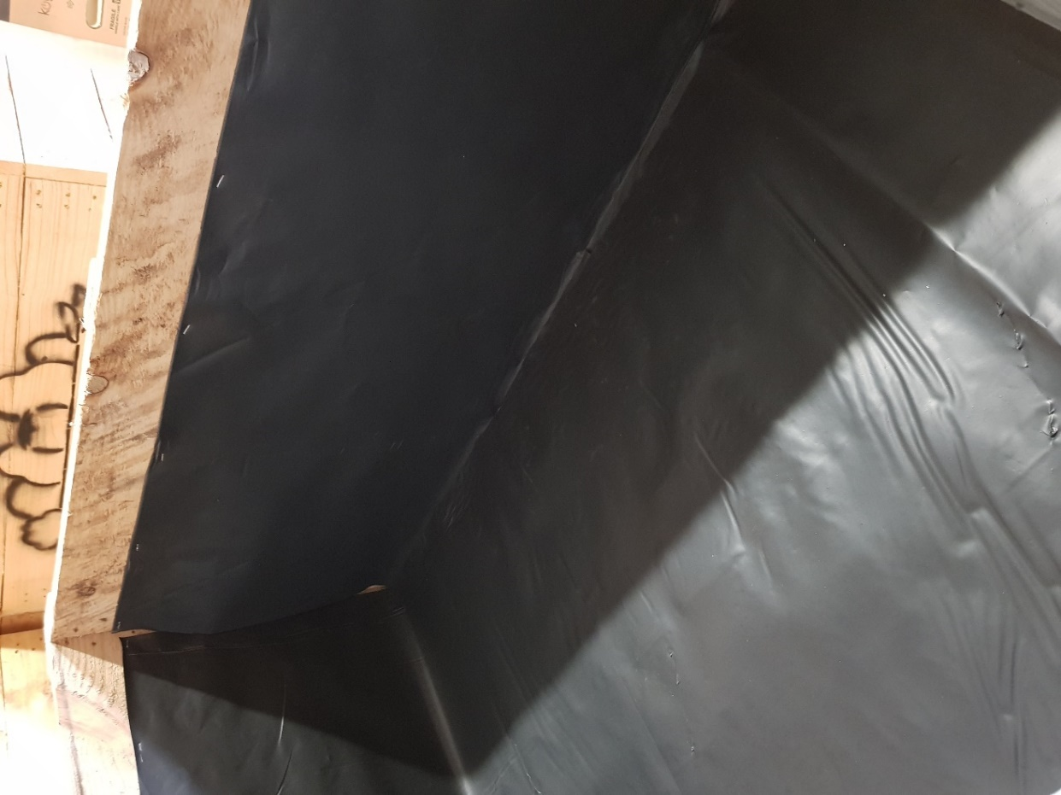

Step 3
Place the large piece of pond liner (2 × 2.5m) into the crate. The crate is longer in 1 direction so make sure the longest part of the black plastic goes in this direction. This is the trickiest part of the process and needs to be done well. Imagine you are wrapping a present, only inside out. Keep the short sides of the liner flat, without any folding to minimise the number of folds you need to do. The folding on the long sides needs to be done as neatly as possible to avoid tearing or puncturing the liner, think hospital or military corners. Ensure the edges of the liner are at the top of the box otherwise water will leak out the bottom of the box.
Once you are happy with the liner, use clamps (or similar) to hold the liner in place.

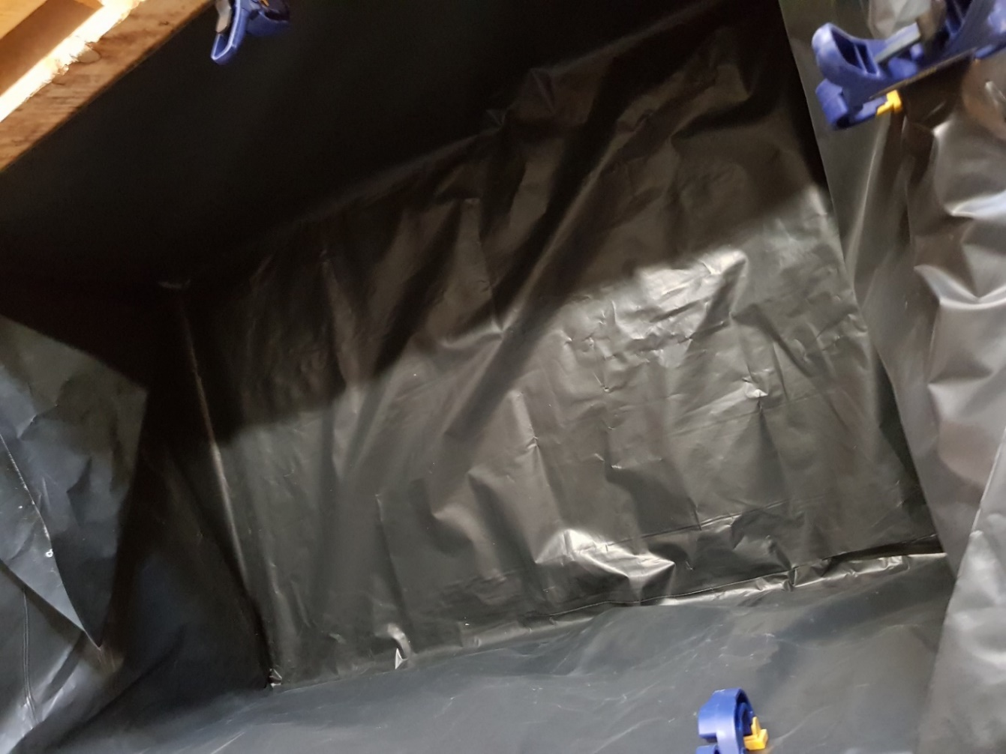
Step 4
Use a knife to pierce a hole through the liners from the inside of the box for the overflow pipe where the hole in the box is. Unscrew the elbow and the screw fitting and the silicon washer. Insert through the box from the inside and put washer and screw fitting on the outside and tighten firmly by hand (note – picture shows pipe in a box without liners). Attach the elbow to the pipe on the outside. If you find the outlet pipe is too long for your liking, you can remove up to 4cm from the length and still fit the elbow in place.
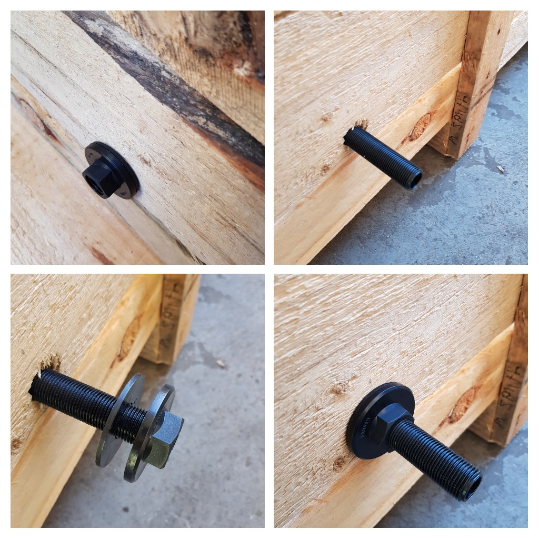

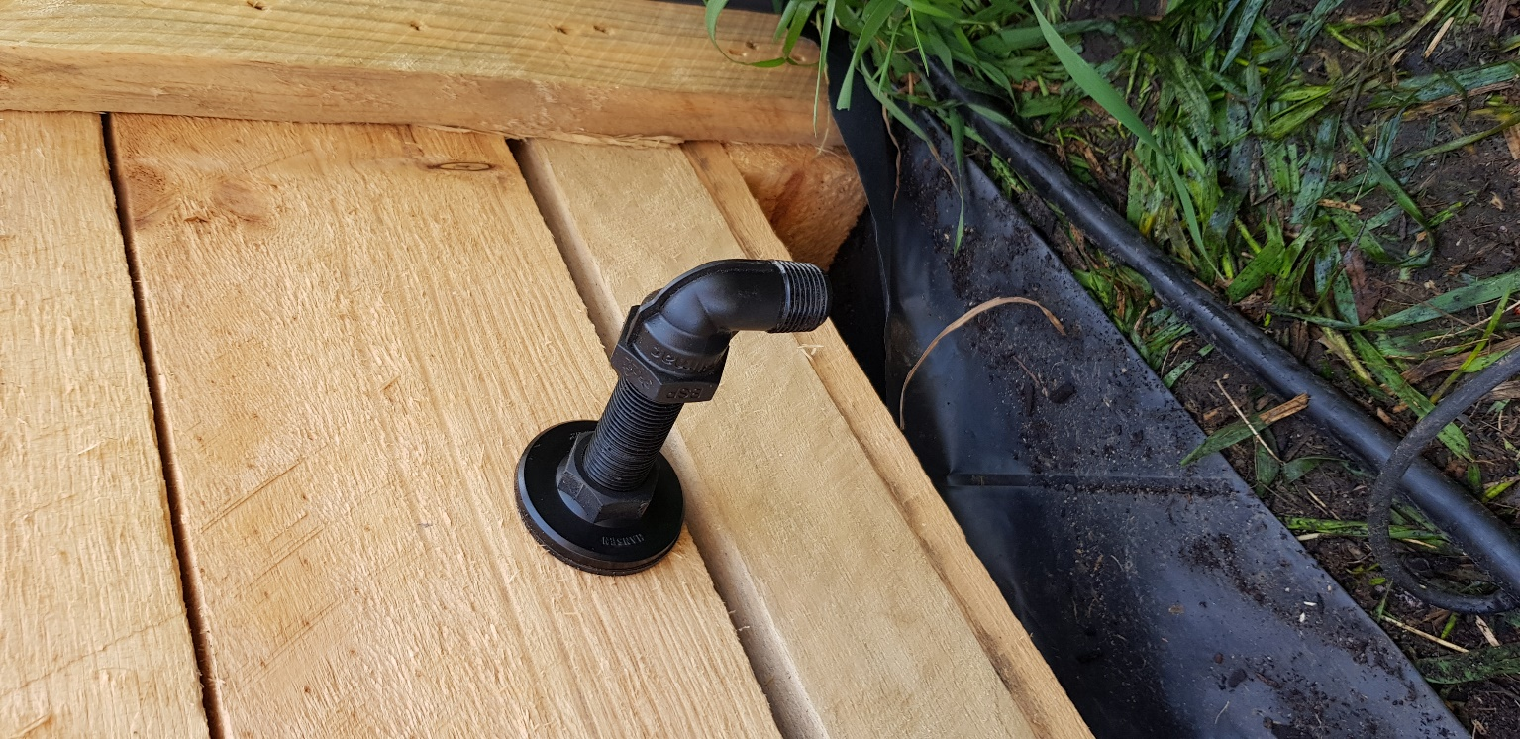

Step 5
Place the wicking cell with the PVC pipe attached to it in the bed with the pipe closest to the edge of the bed and the overflow pipe fitted in the area of the cell that has been modified as shown in the picture. Place the other 5 wicking cells in the box. Place the geotextile cloth around the inside of the box being careful not to cover the wicking legs. Secure it to the side with duct tape.

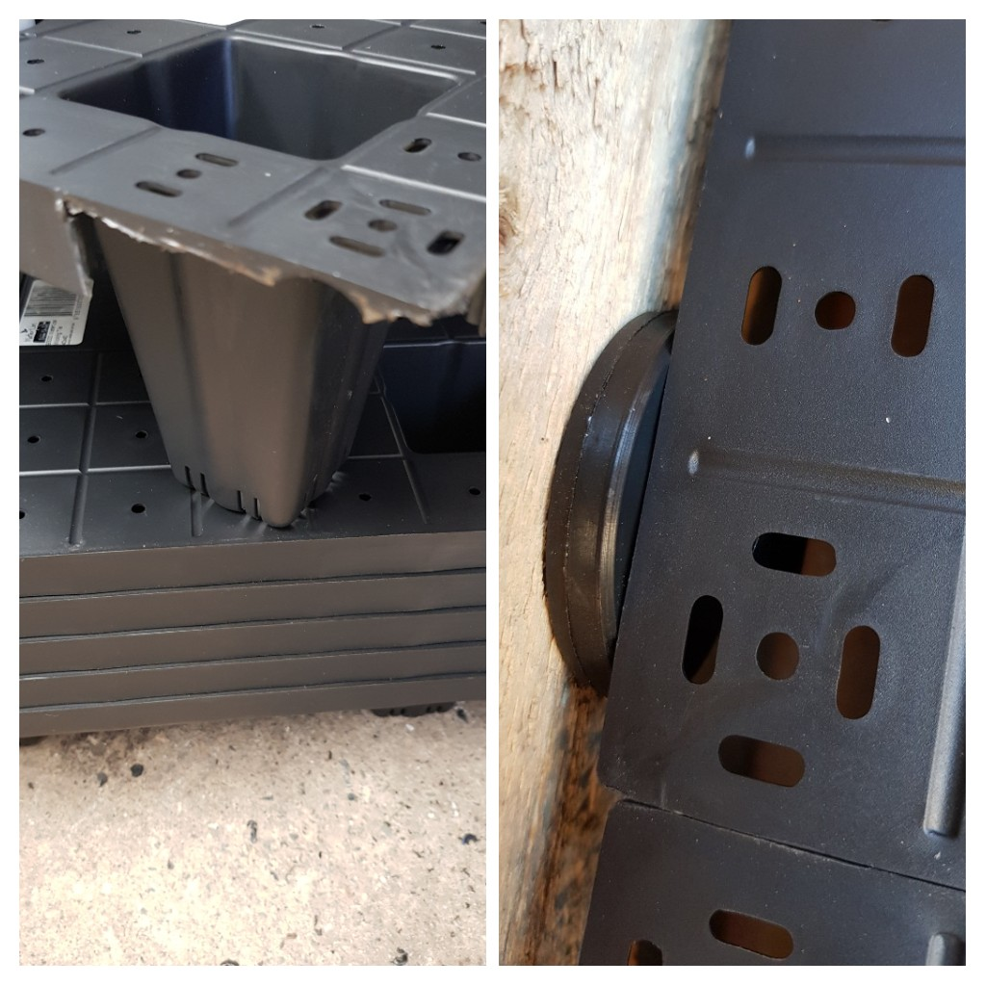
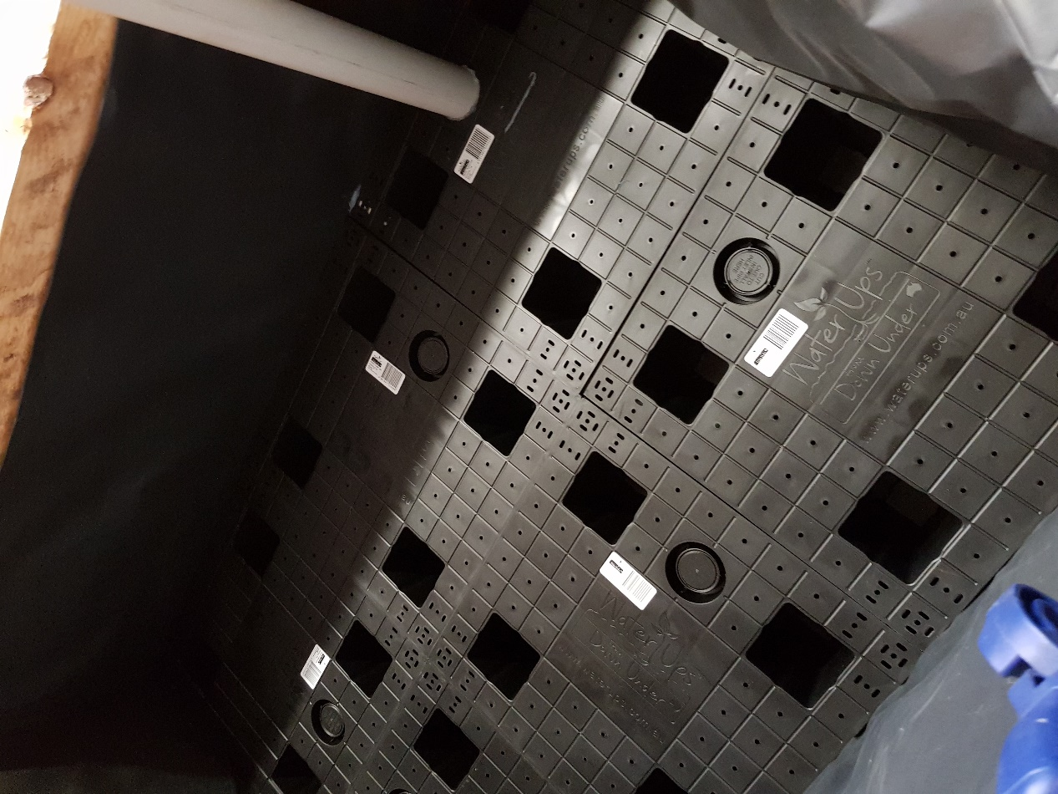

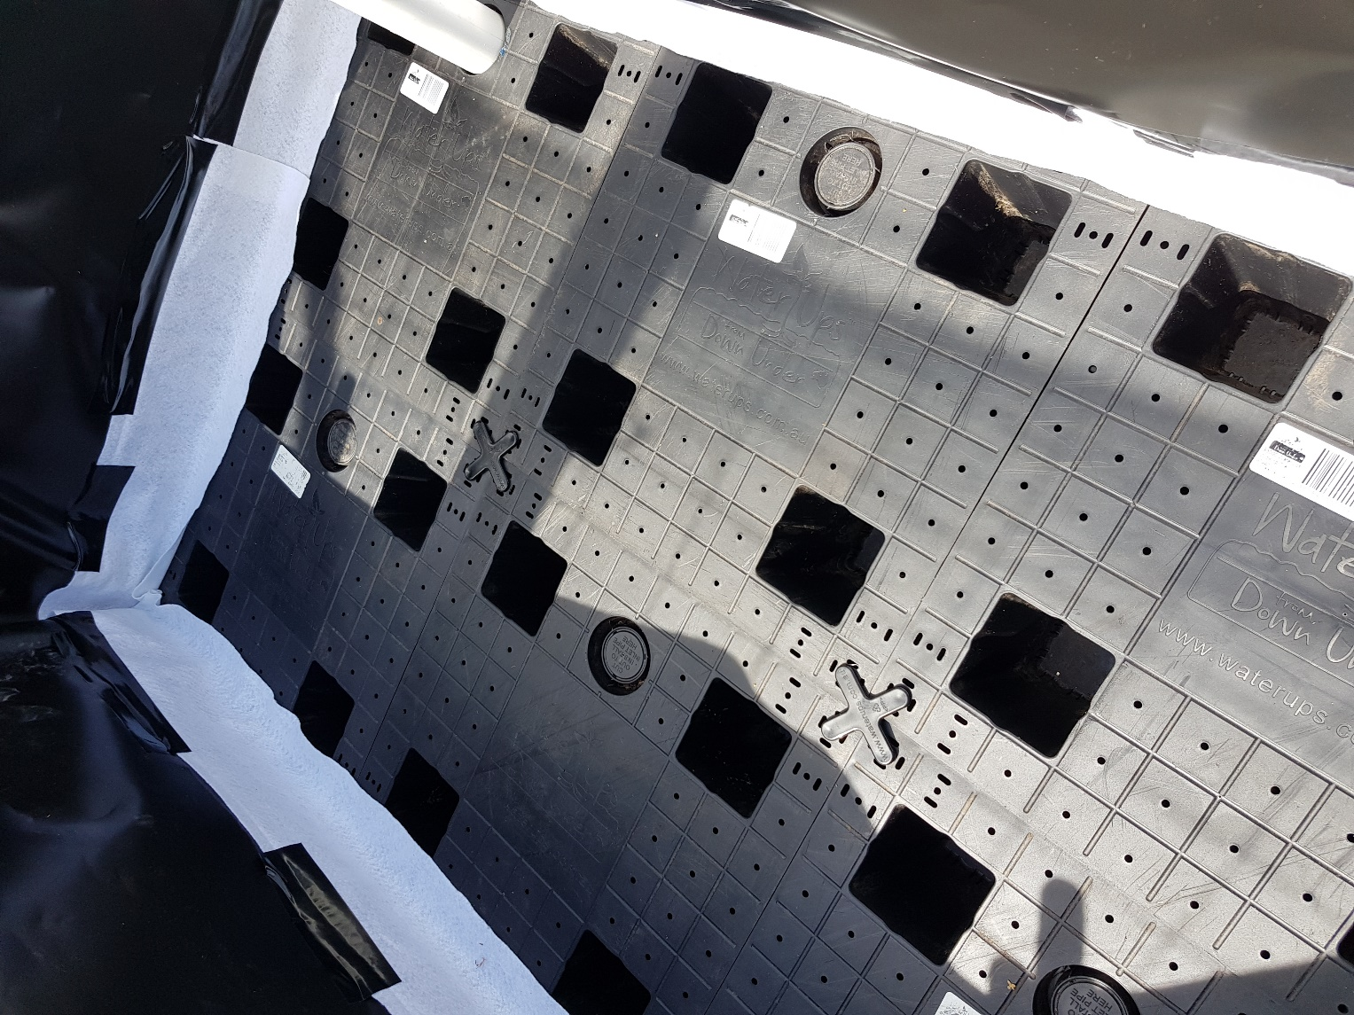

Step 6
First, spray water over the cells and the sides of the beds (this helps the soil to stick to the cells and not fall through any holes/gaps) then fill the ‘wicks’, the 4 legs of each wicking cell, with the perlite (note picture shows a different bed). This aids the wicking process and provides better aeration. Slowly fill the crate with soil until it is half full adding coir, a handful of blood and bone, a shovel full of manure per wheelbarrow load, level it off, remove the clamps holding the plastic liner in place and then fill the reservoir with water until water comes out the overflow pipe. This allows the liner to adjust to the extra tension of the water. Once the water reservoir is full you can secure the main liner to the box using staples/nails and cut the excess to the level of the box. Continue adding the soil, coir, manure/organic fertilisers to the top, allowing space next to the PVC pipe to place the worm farm. Lightly compact the soil as you go filling to just below the top, note that the soil level will sink slightly over the course of the week as the water starts to wick up and the soil settles. The top of the worm farm should be at the soil level. Add the worm farm cover. Add plants! You will need to water new seedlings in until their roots grow and reach the wicking zone which starts 5-10cm below the soil surface. Apply a layer of mulch to keep the top of the soil cooler. The bags the perlite came in can be ripped up and placed in the worm farm, water in thoroughly.

